4. Code Explanation Comments
HTML Structure Explanation:
Form element: Uses method="POST" for secure data submission and novalidate attribute to implement custom validation instead of browser defaults
Input fields: Each field has a unique id for JavaScript access and name attribute for form submission
Error divs: Positioned below each field to display validation messages dynamically
Preview section: Initially hidden, displays when user clicks Preview button to simulate GET method data display
CSS Design Explanation:
Responsive design: Uses flexbox and media queries to ensure form works on all device sizes
Visual feedback: Invalid fields show red border and light red background to guide users
Error messages: Hidden by default using display: none, shown dynamically with .show class
Accessibility: High contrast colors and clear focus states for keyboard navigation
JavaScript Validation Explanation:
Modular functions: Each validation type has its own function for maintainability
Real-time validation: Fields validate on blur (when user leaves field) for immediate feedback
Pattern matching: Uses regex for email and phone validation as required
Preview feature: Simulates GET method by displaying data on same page without URL parameters
POST submission: Form uses POST method for final submission with validation check
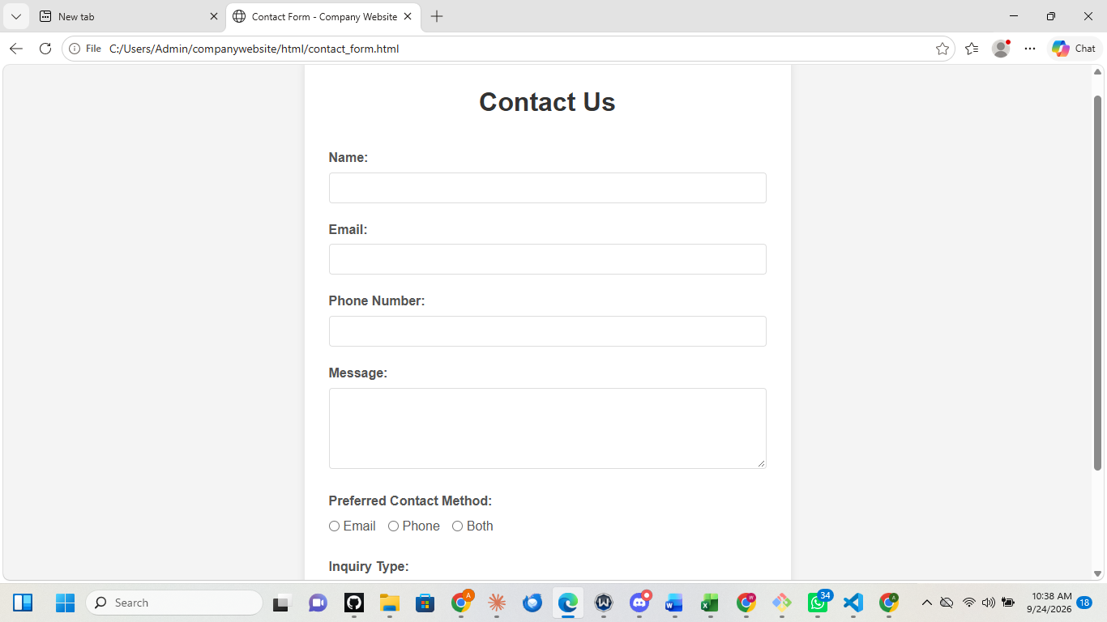

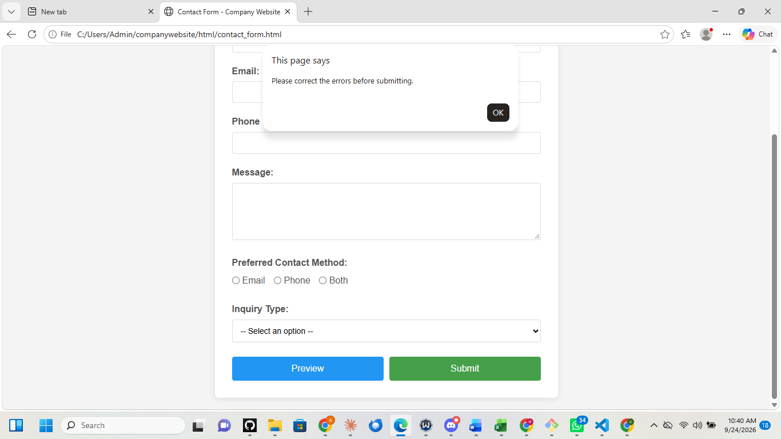

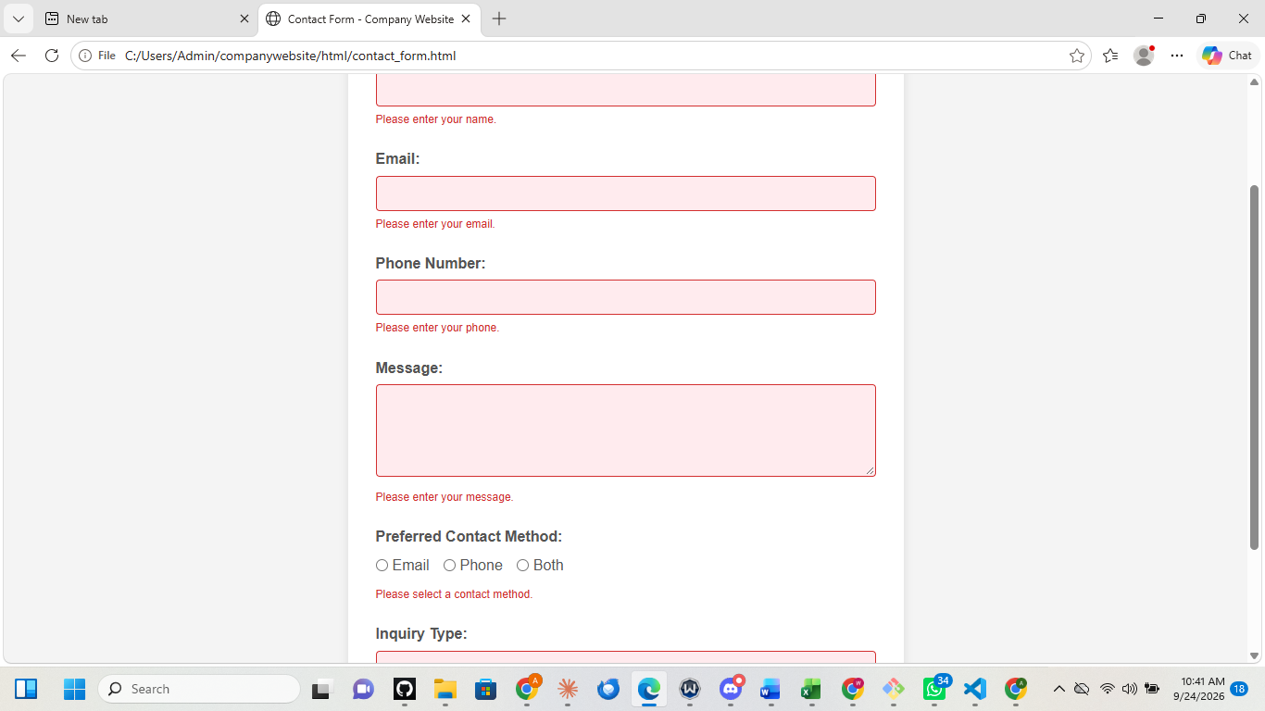

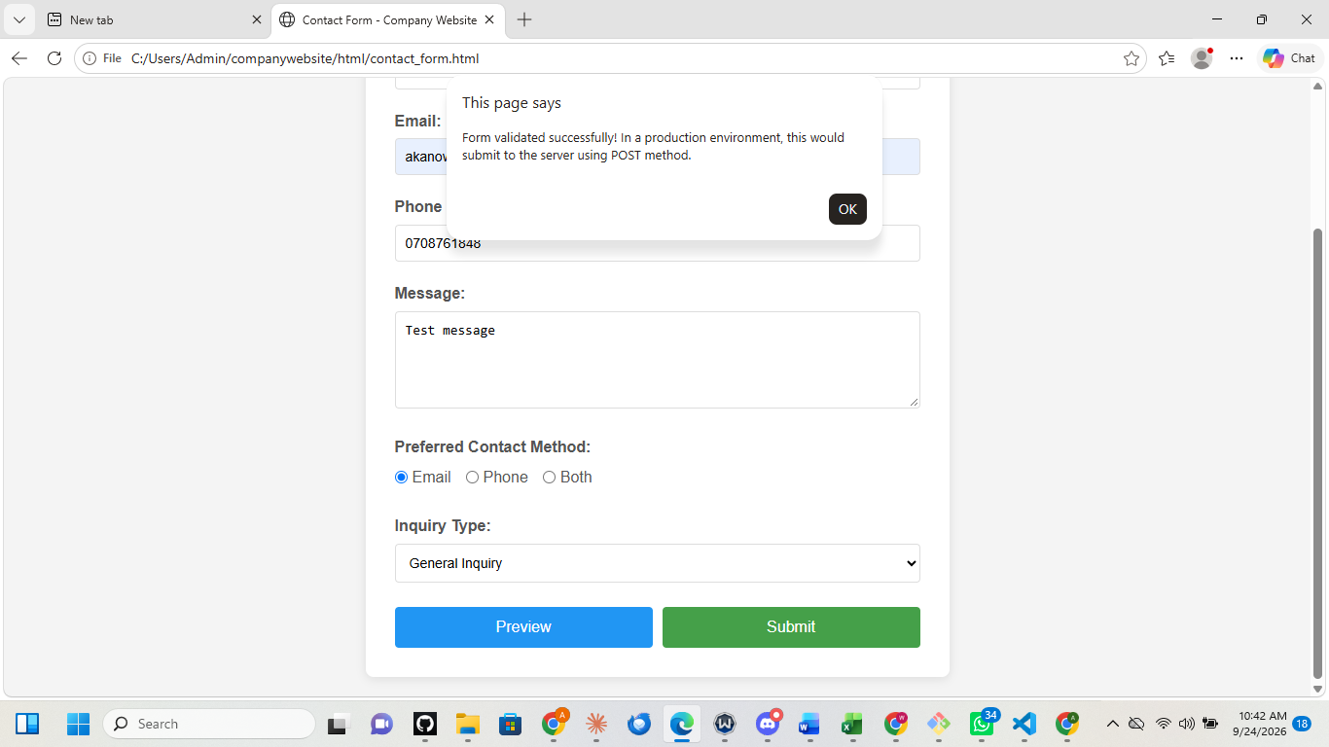

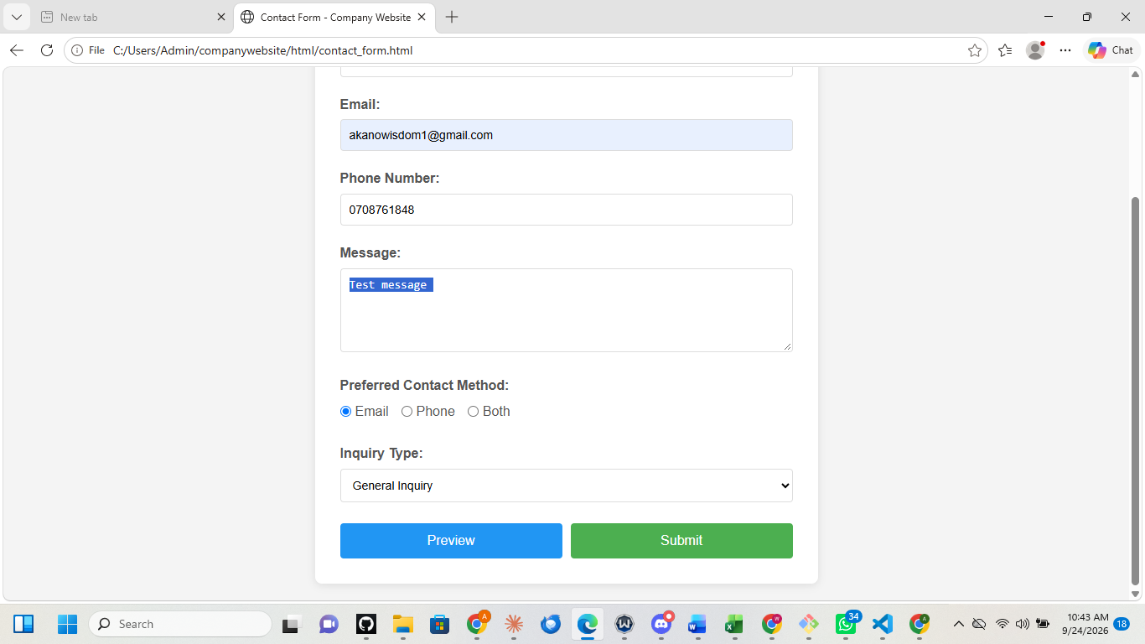
References
Coulson, L., Jephson, B., Larsen, R., Park, M., & Zburlea, M. (2019). The HTML and CSS workshop: Learn to build your own websites and kickstart your career as a web designer or developer. Packt Publishing.

McGrath, M. (2020). HTML in easy steps (9th ed.). In Easy Steps Limited.

Mozilla Developer Network. (2024). HTML forms guide. MDN Web Docs. https://developer.mozilla.org/en-US/docs/Learn/Forms

Mozilla Developer Network. (2024). Client-side form validation. MDN Web Docs. https://developer.mozilla.org/en-US/docs/Learn/Forms/Form_validation

W3C. (2024). HTML5 form elements. World Wide Web Consortium. https://www.w3.org/TR/html52/sec-forms.html

W3Schools. (2024). HTML form validation. W3Schools.com. https://www.w3schools.com/html/html_form_attributes.asp

